**CSC424 Fall 2016**

**Lab 2 – Single Table SQL Queries: Premiere database**

Construct the following queries in SQL and execute them in MySQL database you have created (The Premiere database).

Your output for each query must contain the SQL code and the resulting table. You can copy & paste your SQL code and output table below each query question. You can submit your lab report in a MS Word or PDF file via Blackboard. I will also look at your work in class.

1) List the names of customers with credit limits of $7,500 0r less.

*(P&L page 125 # 3)*

*Query: SELECT * FROM premiere.customer WHERE premiere.customer.CREDIT_LIMIT <= 7500;*

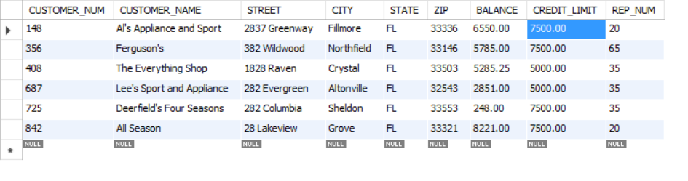

2) List the order number for each order placed by customer 148 on 10/23/2007. *Hint:* The default DATE data type in MySQL stores dates in the format

‘yyyy-mm-dd’, enclosed in single quotes. *(P&L page 125 # 4)*

*Query: SELECT ORDER_NUM FROM premiere.orders WHERE premiere.orders.CUSTOMER_NUM = 148 AND ORDER_DATE = '2007-10-23';*

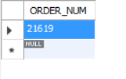

3) Find all customers whose balances are less than their credit limits.

Query: SELECT * FROM premiere.customer WHERE (premiere.customer.BALANCE < premiere.customer.CREDIT_LIMIT);

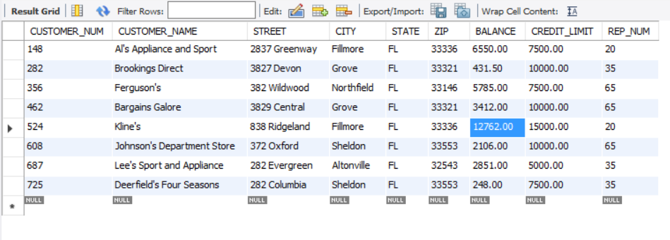

4) How many customers have balances which are less than their credit limits.

*(P&L page 125 #14)*

Query: SELECT COUNT(*) FROM premiere.customer WHERE (premiere.customer.BALANCE < premiere.customer.CREDIT_LIMIT);

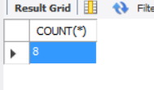

5) Find the total of the balances for all customers whose sales rep is 65 and

whose balances are less than their credit limits. *(P&L page 125 #15)*

Query: SELECT SUM(premiere.customer.BALANCE) FROM premiere.customer WHERE premiere.customer.REP_NUM = 65 AND (premiere.customer.BALANCE < premiere.customer.CREDIT_LIMIT);

